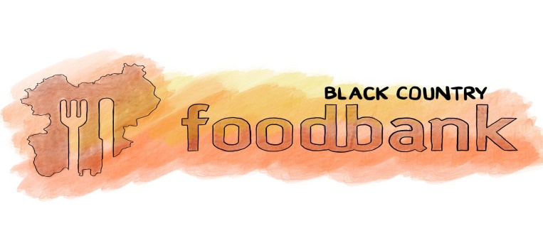

Harvest Shopping List

Please could you bring in any item from this list to donate to the Foodbank.

- Long Life Milk
- Fruit Juice
- Jam/Marmalade
- Tinned Rice Pudding/Custard
- Breakfast Cereal
- Tinned Ready Meals (Chilli/Meatballs)
- Tinned Veg Ready Meals (Curry/Ratatouille)
- Tinned Fish
- Cooking sauces
- Hot chocolate
- Small Jars of Coffee
- Tinned Fruit (in juice preferably)
- Biscuits
- Packets of Mashed Potato
- Healthy Snacks (Small boxes of raisins/apricots)
- Toothbrushes
- Baby Bath & Shampoo
- Roll on Deodorant (Male & Female)
- Shaving Gel/Foam

You can also donate financially at www.justgiving.com/blackcountryfoodbank
Thank you for your support
Black Country Food Bank is a UK registered Charity No. 1136676

