**HARVEST 2017**

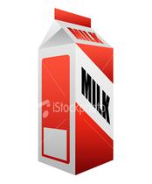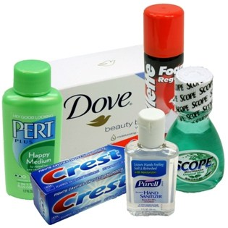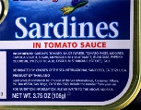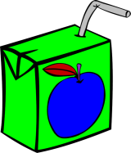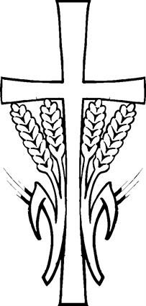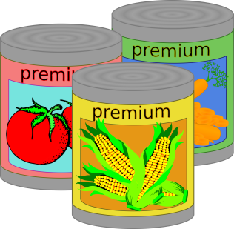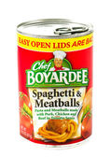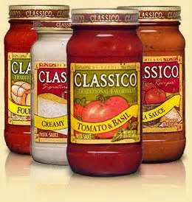

Our Harvest collection this year is to support the work of Black Country Foodbank.

Last year, with your help, Black Country Foodbank gave out 170,000 meals to people in crisis.

Help us keep up the good work by bringing in an item from our Shopping List.

Thank you for your support.

*‘For I was hungry and you gave me food, I was thirsty and you gave me drink,’*

Matthew 25:35