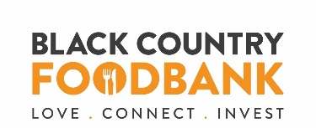

Dear All,
We trust you have settled back into schools and found a new norm. The times that we find ourselves in are challenging. As you can imagine Black Country Foodbank has seen numbers of people using the foodbank increase considerably during the months of lockdown and we anticipate that demand will surge again once the furlough scheme ends and Christmas approaches.
With autumn being the traditional time for Harvest Festivals and donating food, we at Black Country Foodbank would encourage you to support us this year so that we can continue to help those in your local community who are in crisis.
We have put together a small pack of classroom activities and an assembly PowerPoint to help deliver the harvest message and the need for foodbanks like ours. All of these resources can also be found online (see link below) along with posters, shopping lists and videos.
If you have any queries or require any additional information please do not hesitate to contact our Dudley and Sandwell Coordinator Lynne Tilby lynne@blackcountryfoodbank.org.uk

Thank you so much for your support
Jen Coleman CEO
.
To donate food or to support us financially follow the link

https://www.blackcountryfoodbank.org.uk/support/donate/

To download resources please follow the link
https://www.blackcountryfoodbank.org.uk/harvest-2020-please-support/

