**Foodbank : Food Parcels**

**Design a day’s menu for one using the food in the parcel.**

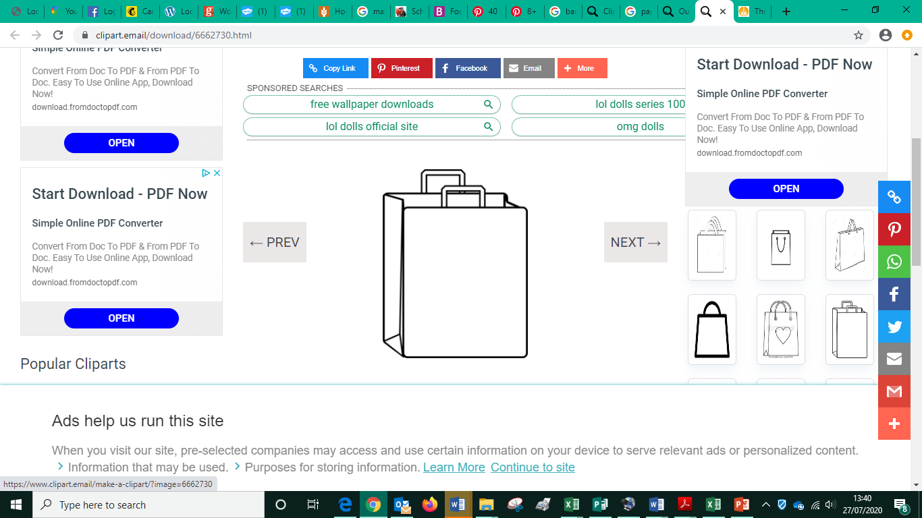

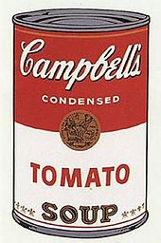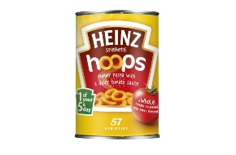

|  |
| --- |
| Breakfast |
|  |

|  |
| --- |
| Lunch |
|  |

|  |
| --- |
| Dinner |
|  |

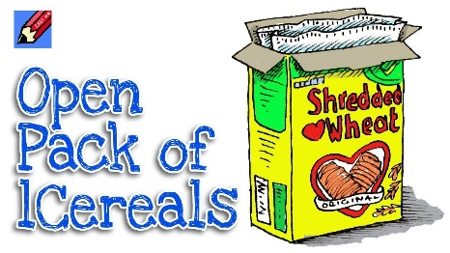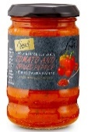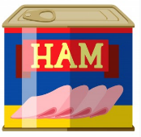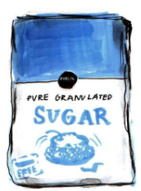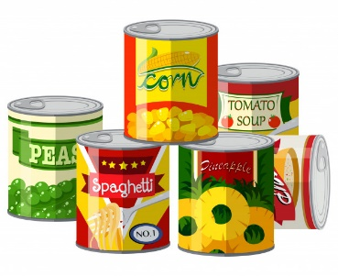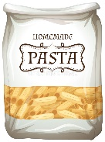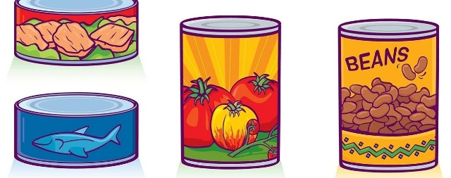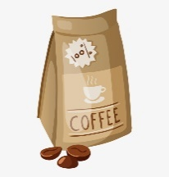

Draw a plate of your favourite food

Cereal

Soup

Spaghetti hoops

Tomatoes

Potatoes

Vegetables

Pasta

Tuna

Tinned meat

Pasta sauce

Fruit

Rice pudding

Milk

Tea

Sugar

Jam

